**DAILY ONLINE ACTIVITIES SUMMARY**

|  |  |  |  |  |  |  |  |  |
| --- | --- | --- | --- | --- | --- | --- | --- | --- |
| **Date:** | **18-06-2020** | | | | | **Name:** | **Anusha** | |
| **Sem & Sec** | **VIII Semester & A Section** | | | | | **USN:** | **4AL16CS014** | |
| **Online Test Summary** | | | | | | | | |
| **Subject** | | **SMS** | | | | | | |
| **Max. Marks** | | **-** | | **Score** | | | **-** | |
| **Certification Course Summary** | | | | | | | | |
| **Course** | **Introduction to EC2 Auto Scaling** | | | | | | | |
| **Certificate Provider** | | | **Amazon Web Service** | | **Duration** | | | **10 minutes** |
| **Coding Challenges** | | | | | | | | |
| **Problem Statement: Magic Numbers** | | | | | | | | |
| **Status: COMPLETED** | | | | | | | | |
| **Uploaded the report in Github** | | | | | **YES** | | | |
| **If yes Repository name** | | | | | **anushasuvarna-014** | | | |
| **Uploaded the report in slack** | | | | | **YES** | | | |

Online Test Details:

NIL

Certification Course 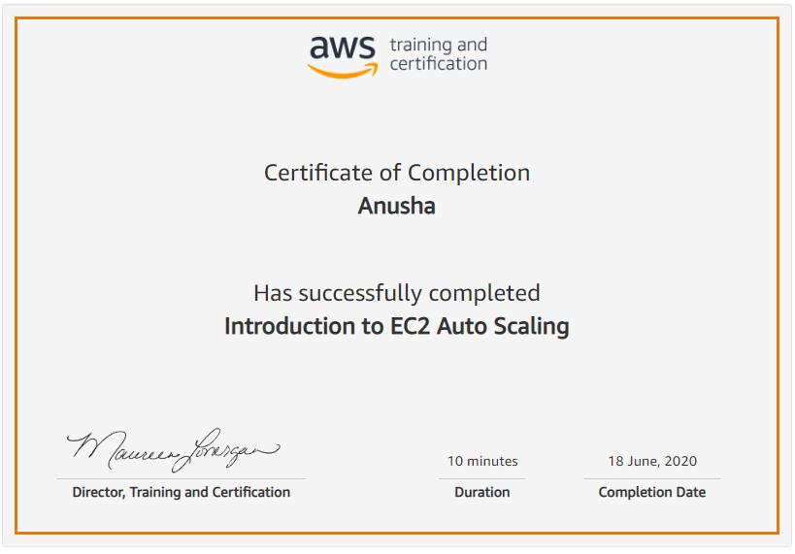

Coding Challenges Details:

|  |
| --- |
|  |
|  |
|  |
|  |
|  |
|  |
|  |
|  |
|  |
|  |
|  |
|  |
|  |
|  |
|  |
|  |
|  |
|  |
|  |
|  |
|  |
|  |
|  |
|  |
|  |
|  |
|  |
|  |
|  |
|  |
|  |
|  |
|  |
|  |
|  |
|  |
|  |
|  |
|  |
|  |
|  |
|  |
|  |
|  |
|  |
|  |
|  |
|  |
|  |
|  |
|  |
|  |
|  |
|  |

**Program1:**

|  |  |  |  |
| --- | --- | --- | --- |
|  | | |  |
| **#include<stdio.h>** |
|  |  | |
|  | **int nthMagicNo(int n)** | |
|  | **{** | |
|  | **int pow = 1, answer = 0;** | |
|  | **while (n)** | |
|  | **{** | |
|  | **pow = pow*5;** | |
|  | **if (n & 1)** | |
|  | **answer += pow;** | |
|  | **n >>= 1;** | |
|  | **}** | |
|  | **return answer;** | |
|  | **}** | |
|  |  | |
|  | **void main()** | |
|  | **{** | |
|  | **int n, i;** | |
|  | **printf("Enter the value of N: ");** | |
|  | **scanf("%d", &n);** | |
|  | **for(i = 1; i <= n; i++)** | |
|  | **{** | |
|  | **printf("%d ", nthMagicNo(i));** | |
|  | **}** | |
|  | **printf("\n");** | |
|  | **}** | |